48 HOURS IN MEDWAY
Explore a rich maritime past lingering long into the present…
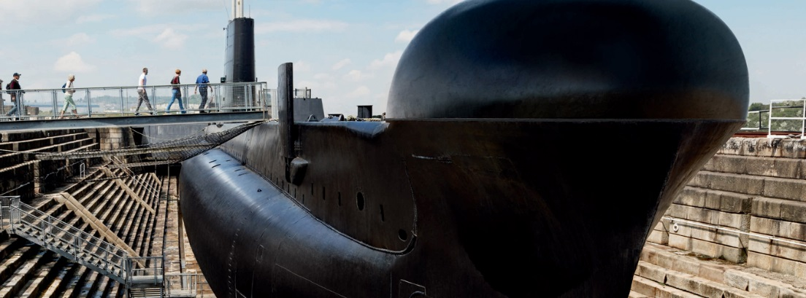

WHY GO NOW?
A historic Royal Dockyard, some imposing coastal defences and spooky, secret wartime tunnels are all waiting to be discovered as you voyage the rich and lively heritage across the Garden of England. Clear the decks, feel the wind in your sails, and push the boat out on a fantastic maritime trip to Kent.
CHECK IN
Find the perfect place to rest your head at Bridgewood Manor Hotel in Rochester. Designed around a wonderful inner courtyard, attentive four-star service goes hand in hand with a superb setting.
DAY 1
RIDE THE RAPIDS
Where better to begin your tour of Kent, than riding the waves of the River Medway? Climb on board the only jet boat in Kent for a 90-minute wet and wild experience with Jet Stream Tours.
KING OF THE CASTLE
Once your feet are standing firmly back on solid ground make your way along the River Medway and enjoy a personal encounter with Upnor Castle.
SPECTACULAR SHIPS
Explore a submarine, command a warship, make your own rope, and set sail for your voyage through England’s naval history at The Historic Dockyard Chatham. Spanning more than 400 years, spend your afternoon discovering the most complete British dockyard from the age of sail!
AN APERITIF?
Raise a glass or two of Medway’s finest spirits at the brand-new Copper Rivet Distillery. Take a tour and experience the entire distillation process from grain to glass. Enjoy a taste of Medway, experience a botanicals masterclass, and have a go at distilling your own gin.

DOCKYARD DINING
To end your day of maritime discovery why not enjoy panoramic views of the pleasure boats and across the River Medway to Upnor Castle? Naval heritage meets contemporary style at the Ship and Trades - a stunning bar, restaurant and hotel in Chatham’s stylish marina. Try to keep your eyes off the water as this wrap-around restaurant boasts fantastic floor to ceiling windows overlooking the marina.
DAY 2
FLORAL FORTRESSES
A right royal way to start the day, venture east of Chatham as you seek out some of Kent’s finest defences sprung along the county’s shores. Try not to lose your head when you arrive at Deal Castle, one of the most elaborate in a chain of fortresses King Henry VIII.
WONDER AT WALMER
Open the door to this charming Tudor castle and explore eight acres of magnificent gardens, woodland, and sea views. Take a fresh look at the castle and see new displays, hear previously untold stories, and discover a new side to its fantastic, famous residents.
DRAMATIC DOVER
Spend an afternoon in White Cliffs Country; explore the curtain walls and inner bailey buildings of King Henry II, and step right into the thick of his life and times in the Great Tower.
SCARE YOURSELF SILLY
Enter at your own pace the eerie, winding Secret Wartime Tunnels that bury deep into the iconic white cliffs of Dover. With vivid recreations telling the story of the Dunkirk evacuation, complete with dramatic projections of swooping Spitfires and real film footage, prepare for a dramatic afternoon descent into Kent’s magnificent maritime life.
COASTAL CATERING
End your trip with a hearty feast fit for King Henry VIII as you head to The Cliffe pub at St Margaret’s At Cliffe, just four miles from Dover Castle. Eat, drink and relax around the fire or wood burner, in surroundings that reflect your coastal position and the pub’s long-standing heritage in the village.

